DRM Support to Gstreamer(Player)
1.Requriements:
1.CDM Modulue Plugin
2.Gstreamer Framework for Player
3.GTK+3.0 tool kit
4.CSS(casecade Style Sheet)
5. GST_DEBUG
2. Design work :
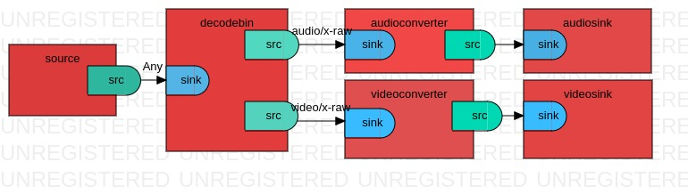

CDM Module
CDM Module

gst-launch-1.0 filesrc location=small.ogv ! CDM MODULE ! decodebin name=dee dee. ! queue ! audioconvert ! audioresample ! autoaudiosink dee. ! queue ! videoconvert ! autovideosink

3.Coding/Implementation
Implemented code for player .

4.Testing
Player tested with around 10 to 15 container formates.
Elements processing time and over all player processing time.
5.Demonstration:

